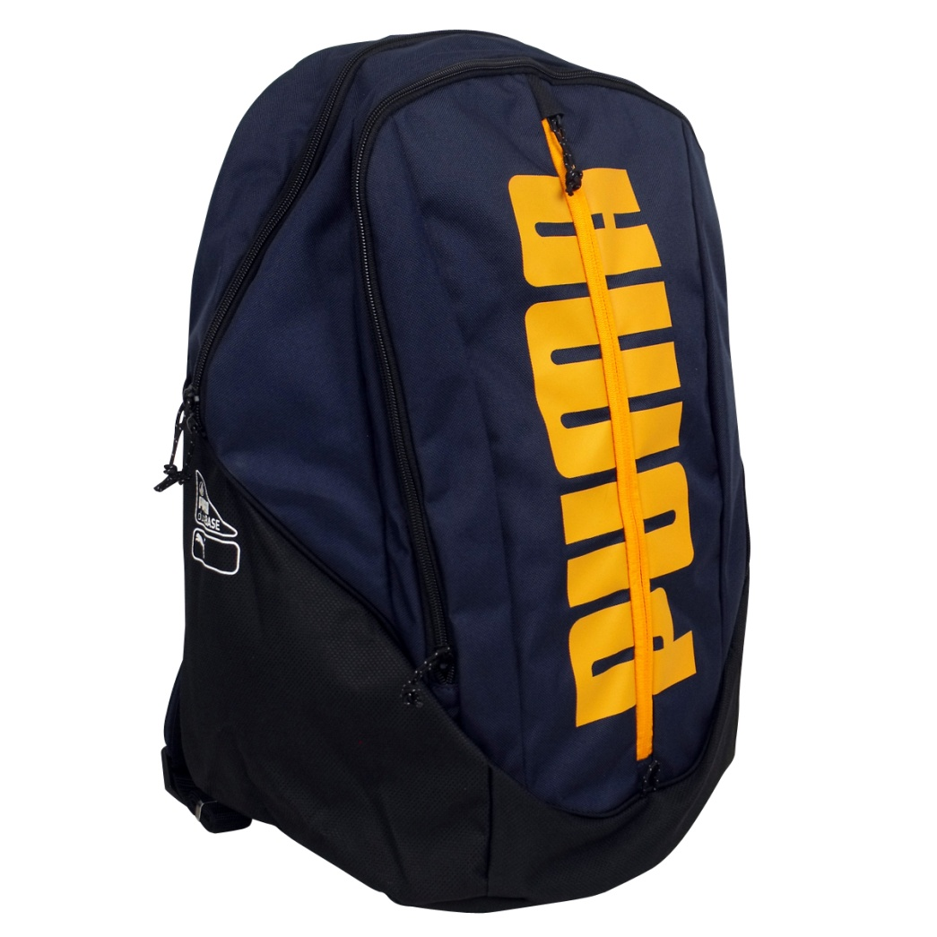

# PUMA NAVY BLUE -015

|  |  |
| --- | --- |
| BRAND | PUMA |
| ITEM DIMENSION | 2 x 4 x 12.13inches |
| MODEL NAME | 015 |
| COLOR | NAVY BLUE |
| PRICE | **RS 1700** |